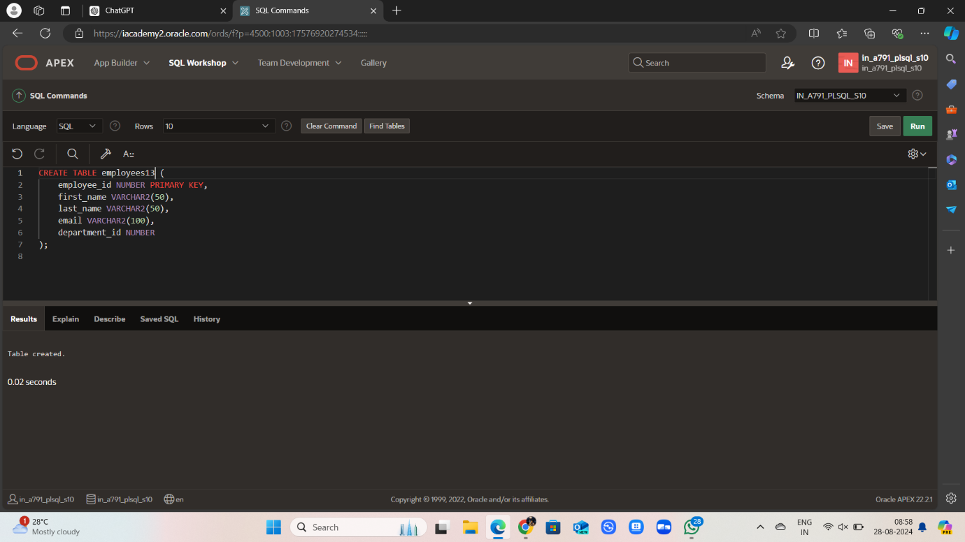

CREATE TABLE employees (

employee_id NUMBER PRIMARY KEY,

first_name VARCHAR2(50),

last_name VARCHAR2(50),

email VARCHAR2(100),

department_id NUMBER

);

INSERT INTO employees (employee_id, first_name, last_name, email, department_id) VALUES (1001, 'John', 'Doe', 'jdoe@example.com', 10);

INSERT INTO employees (employee_id, first_name, last_name, email, department_id) VALUES (1002, 'Jane', 'Smith', 'jsmith@example.com', 10);

ALTER SESSION SET PLSQL_WARNINGS = 'ENABLE:PERFORMANCE';

CREATE OR REPLACE PACKAGE bigarg IS TYPE emptab_type IS TABLE OF employees%ROWTYPE INDEX BY PLS_INTEGER; PROCEDURE getallemps (p_emptab OUT emptab_type); END bigarg;

SELECT line, position, text, attribute FROM USER_ERRORS WHERE name = 'BIGARG';

